**Intelligent Customer Help Desk with Smart Document Understanding** – **SB51613**Project Scope Document

1. Project Summary

In this project, we use the typical customer care chatbot experience, but instead of relying on pre-determined responses, the dialog provides a hook that can call out to other IBM Watson services for additional sources of information. In this case, its an owner manual that has been uploaded to Watson Discovery.

2. Project Requirements:

i) Create a customer care dialog skill in Watson Assistant.

ii) Smart Document Understanding (SDU) to build an enhanced Watson Discovery collection.

iii) Create an IBM Cloud functions web action that allows Watson Assistant to post queries to Watson discovery.

iv) Build a web application with integration to all these services and deploy the same on IBM Cloud Platform.

**2.1 Functional Requirements:**

[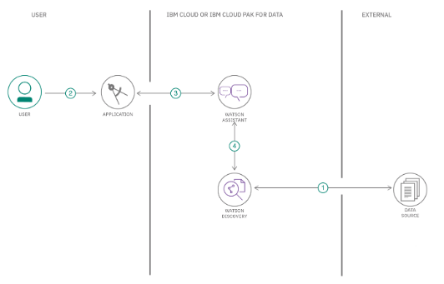](https://user-images.githubusercontent.com/64901867/81792927-55dc0580-9526-11ea-9339-8c817ecac130.PNG)

**Step-1:** The data source from external is annotated by using Watson Discovery Smart Document Understanding.

**Step-2:** The user interacts with the back-end server through the application user interface. The front-end app user

interface is a chatbot that engages the user in a conversaton.

**Step-3:** Dialog between the user and back-end server is coordinated using a Watson Assistant dialog skill.

**Step-4:** If the user asks a question that falls outside of the scope of the pre-determined question set, then a search

query is issued to the Watson Discovery service through a Watson Assistant search skill.

**2.2 Technical Requirements:**  
 Python, IBM Cloud, IBM Watson Studio, Node-RED

**Hardware Requirements:**  
 Processor-i3 7th generation or higher  
 Speed: 2 GHz or more

**3. Research of Previous:**

In building this project we use the data from Kaggle. Which helps to build the model.

**4. Algorithms:**

Using Watson studio with Juyter notebook import python library and helper function.

from sklearn.linear_model import LinearRegression, Lasso, Ridge, etc.

Create a data frame.

Checking missing data then normalizing it.

Create Training and Test Sets.

Extract just the numeric values for the features and labels as the TensorFlow model will expect just numeric values as input.

Create a model then train it.

Prediction of life expectancy.

**5. Deliverable**

A machine learning model that will predict life expectancy(software).

**6. Out of Scope**

In the project, the user will not able to modify or not able to increase the accuracy of the ML model.

**7. Project Team**

* Shubham (Individual)

**8. Project Schedule**

|  |  |
| --- | --- |
| Task | Days |
| 1. Git 2. Zoho Writer 3. IBM Cloud Services 4. Watson Studio 5. Node-RED | 0.5 day (20/06/2020)  0.5 day (20/06/2020)  1 day (21/06/2020)  3 days (22/06/2020)  2 days (25/06/2020) |
| 1. Documentation 2. Data Preprocessing 3. ML Algorithms 4. Node-RED Integration | 1 day (27/06/2020)  2 days (29/06/2020)  3 days (02/06/2020)  1 day (06/06/2020) |

Project Planning & Kickoff - 1day

Setup the Development Environment - 1 day

Create IBM Cloud Account - 0.5 day

Create a Node_RED Starter Application - 1 day

Explore IBM Watson Usecases - 0.5 day

Introduction to Watson Assistance - 2 days

Introduction to Watson Discovery- 2 days

Getting Started with IBM Cloud Functions - 1 day

Create necessary IBM Cloud services - 1 day

Configure Watson Discovery Service - 1 day

Create cloud functions action - 1 day

Configure Watson Assistant - 1 day

Build Node-RED flow to integrate all services - 2 days

Build a web dashboard - 1 day

Test the Bot and capture the results - 1 day

Prepare the project report and upload the Node_RED flow to GitHub - 1 day

Create a project Demo Video and upload to youtube - 1 day